**Datawarehouse & Data Lake**

Datawarehouse and Data Lake are complimentary but have different benefits. They both exists in most of the enterprise environment.

* Data Lake supports machine learning and open to any format. They have poor support for business intelligence and complex data.
* Datawarehouse are great for business intelligence application but have limited support for machine learning workloads.

A data lakehouse can be defined as a modern data platform built from a combination of a data lake and a data warehouse. More specifically, a data lakehouse takes the flexible storage of unstructured data from a data lake and the management features and tools from data warehouses, then strategically implements them together as a larger system.

The Databricks Lakehouse combines the ACID transactions and data governance of data warehouses with the flexibility and cost-efficiency of data lakes to enable business intelligence (BI) and machine learning (ML) on all data.

**Limitation of Data Lake:**

* Unreliable data since it is coming from different sources and when the volume of data increases maintaining reliable data is challenging. This leads to in-accurate query result.
* Poor performance since volume is high, query results takes time.
* Hard to secure

**Delta Lake**

To solve the challenges faces by data lake delta lake have been introduced. It is a data storage and management layer for your data lake.

At the heart of the data lake sits delta lake, it provides the ability to build a curated data lake. It Provides reliability, performance and data governance which is expected out of data lake.

Delta Lake allows us to incrementally improve the quality until it is ready for consumption. Data flows like water in Delta Lake from one stage to another stage (Bronze -> Silver -> Gold).

* Delta lake brings full ACID transactions to Apache Spark. That means jobs will either complete or not at all.
* Delta is open-sourced by Apache. You can store a large amount of data without worrying about locking.
* Delta lake is deeply powdered by Apache Spark which means that the Spark jobs (batch/stream) can be converted without writing those from scratch.

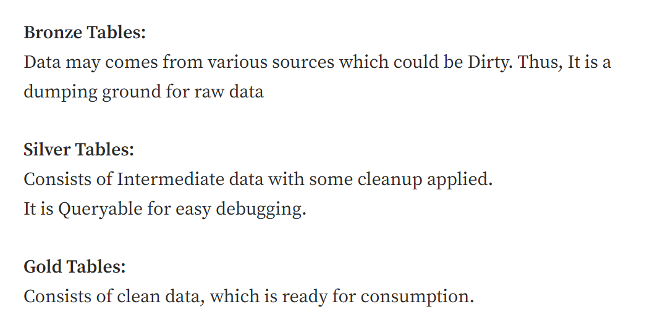

Advantages: -

* Increase productivity
* Advanced indexing
* Schema enforcement

**ACID Properties: -**

**Atomicity –** All or nothing, Success or failure. If there is some failure system need to revert back to previous state.

**Consistency –** The Db should be remained preserve always. The correctness of DB should be there before and after any transaction.

**Isolation –** Multiple transaction can occur simultaneously without leading any inconsistency in db.

**Durability –** It ensure permanency of something. Even if the system fails the changes should be the db should still survive.

**Problem solved by ACID: -**

* Hard to append data
* Modification of existing data is difficult –> Upsert command to update insert
* Job failing midway -> data will not be committed until job is completed successfully
* Real time operation is hard
* Costly to keep historical data version.

#_#_#_#_#_#_#_#_#_#_#_#_#_#_#_#_#_#_#_#_#_#_#_#_#_#_#_#_#_#_#_#_#_#_#_#_#_#_#_#_#_#_#_#_#_#_#_#_#_#_#_#_#_#_#_#_#_#_#_#

**Apache Spark**

MapReduce was not sufficient for iterative and interactive application. So Spark was introduced to overcome the deficiency of MapReduce. It is a platform for cluster computing, this means that we can install spark in different systems and group them as cluster and execute any tasks.

1. The most important feature of spark is **in-memory** computation. It can directly fetch data into RAM and can process it giving desired result. If the RAM is 4gb and data to process is 10gb then it will process 4gb data on RAM and rest 6gb data on the disk. In Hadoop also data is processed on the disk.

|  |
| --- |
| Hadoop keeps intermediate data on disk, spark keeps intermediate data in memory to reduce the reads and writes from disk. In MapReduce there are too many trips to HDFS, it has to read and write data multiple times from disk. SO when I say "In hadoop data is processed on disk", the data I am referring to is intermediate data. |

1. Spark is designed to perform wide range of tasks (batch application, ML, streaming, interactive query, structure data processing).

|  |
| --- |
| Hadoop was also performing wide range of task but Its own component was doing these tasks. For example – for structure data processing we needed to install hive over Hadoop. For ML we needed mahout to be installed. |

1. Spark is a distributed computing platform.
2. It integrates with other big data tools.
3. Easy and inexpensive.

**Cluster Manager**

Spark is installed on top of cluster manager. Cluster Manager is one of the important components in the Spark Architecture**. It allocates and deallocates** the resources when any spark job is executed. The task will come from driver. CM will check on which **system(worker node)** the data is present which is needed to execute the task. It will also check if there is resource (RAM) present on the worker node to execute the task. It will then assign the task to executor in worker node.

When the execution of Spark application is complete, CM will deallocate all the resource responsible to execute the task.

1. Hadoop YARN
2. Apache Mesos
3. Standalone scheduler – install spark on empty set of machines

**Storage Layer for Spark**

From where spark can pick the data and process it.

1. HDFS and other storage system supported by Hadoop APIs. (local file system, ADLS, amazon S3, Cassandra, etc..)
2. Support text files like Avro, parquet, text, csv and other Hadoop input format.

**RDD**

Resilient Distributed dataset - In simple layman terms it is a dataset which is distributed across various nodes and have ability to repair itself(resilient). It is immutable data can’t be changes once created. However, it can be overridden.

**Features of RDD –**

1. Fault tolerant distributed dataset.

RDD is fault-tolerant because of the following reasons:

* **Immutable nature:** RDDs are immutable, meaning once an RDD is created, it cannot be modified. Instead, any transformation applied to the RDD creates a new RDD. This immutability property ensures that RDDs are resilient to faults because, in case of a node failure or data corruption, the original RDD is still available for use.
* **Lineage Graph:** RDDs maintain a lineage graph that records the transformations applied to the RDD. This lineage graph allows RDDs to recover lost data or reconstruct the RDD in case of a node failure. The lineage graph enables RDDs to recompute lost partitions by applying the transformations to the original RDD.
* **Data Partitioning:** RDDs store data in partitions across the cluster. Each partition is replicated across multiple nodes, ensuring that the data is available in case of a node failure. This partitioning and replication of data also help in reducing data transfer and network overhead.
* **Automatic Recovery:** In case of a node failure, RDDs can automatically recover the lost data or recreate the lost partition by using the lineage graph. This automatic recovery ensures that the processing is not affected, and the system remains fault-tolerant.

1. Lazy Evaluation – **Execution doesn’t happen until any action is called.**
2. Caching – **The dataset which is required most frequently can be put in cache memory (RAM).**
3. In- Memory computation
4. Immutability
5. Partitioning - Data is split in partition. It is to distribute data across multiple nodes in a cluster. Partitioning is a key feature of RDDs, and it helps in achieving parallelism by distributing data processing across multiple nodes.

Data is divided into partitions, where each partition is a logical unit of data that can be processed independently. Each partition can be processed on a separate node in a cluster, allowing for parallel processing of the data. The number of partitions in an RDD can be specified by the user or determined automatically by the Spark engine based on the size of the input data and available resources.

Two types of portioning are –

* **Hash Partitioning:** In hash partitioning, data is partitioned based on a hash function applied to the data key. The hash function returns a partition ID, which is used to determine the partition in which the data will be stored. Hash partitioning is a good option when the data does not have an inherent ordering, and we want to evenly distribute the data across the nodes.
* **Range Partitioning:** In range partitioning, data is partitioned based on a range of values. For example, if we have a set of data with timestamps, we can partition the data based on time ranges, such as partitioning all data from 9 AM to 10 AM into one partition, and all data from 10 AM to 11 AM into another partition. Range partitioning is useful when we want to process the data based on some natural ordering.

**can we restrict Partitioning in spark...?**

When creating an RDD in Spark, you can specify the number of partitions to be created, or you can use a default value provided by Spark. For example, when reading data from a file, Spark uses the default parallelism, which is the number of cores available on the cluster. You can also use the repartition() or coalesce() method to control the number of partitions in an RDD.

repartition() is used to increase or decrease the number of partitions in an RDD. It shuffles the data across the cluster to create new partitions, which can be more or less than the original number of partitions. For example, you can use rdd.repartition(10) to create 10 partitions in the RDD.

coalesce() is used to decrease the number of partitions in an RDD. It avoids shuffling the data across the cluster and instead, merges some partitions together to reduce the total number of partitions. For example, you can use rdd.coalesce(5) to reduce the number of partitions to 5

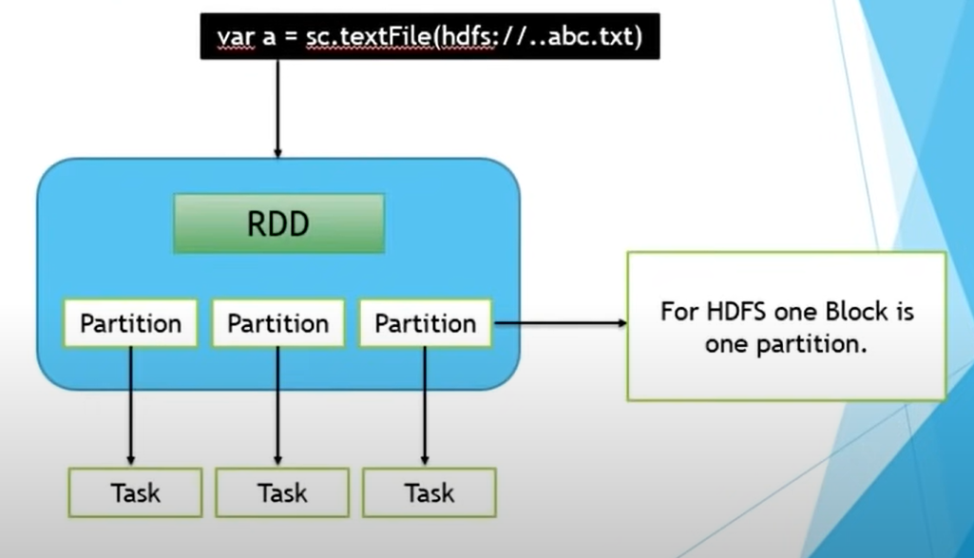

RDD has two operations -

1. **Transformations** – Process of making a RDD from a different RDD is called transformation. When there is transformation happening, nothing is getting executed. Transformation is a kind of operation which will transform Dataframe from one form to onother. We will get new Dataframe after execution of each transformation operations.

**Var a = sc**.textfile(“hdfs://……………./abc.txt) -- RDD0

**Var b = a**.filter(…) -- RDD1

**Var c = b**.distinct(….) -- RDD2

**Nothing is getting executed while transformation doesn’t** mean that spark is sitting idle, it creates a DAG (Directed Acyclic Graph). DAG is an execution map which contains the step-by-step execution plan like which RDD is created 1st, what operations were done on RDD1 and RDD2 is created.

**Narrow Transformation –** Does not require shuffling data across nodes. The code mentioned in the picture can be executed independently across different nodes. Simple and in-expensive transformation.

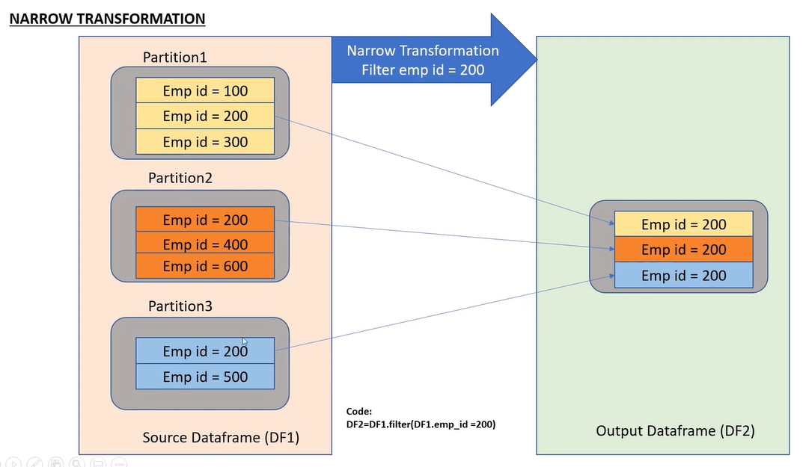

**Wide Transformation –** Doe require shuffling data across nodes. The output can only be produced one data is shuffled across all the nodes. It is expensive operation and will hit the performance.

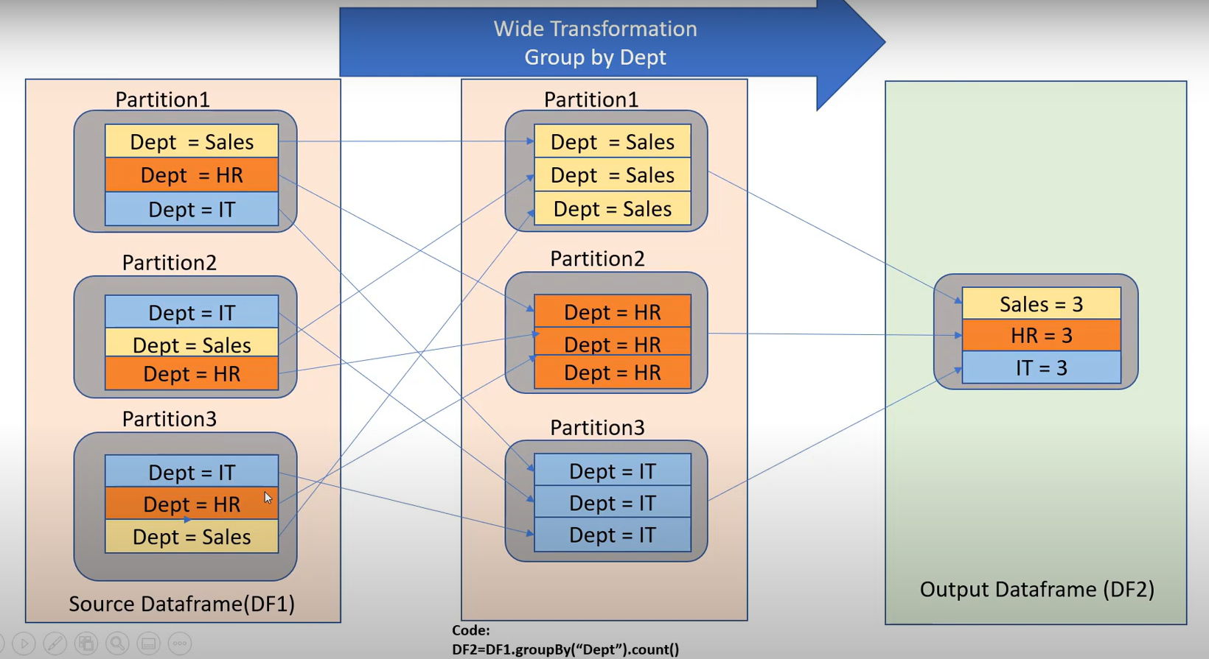

1. **Actions –** When all the transformation is complete on the data the actions are invoked to collect the data. The execution start on the cluster only when an action is called. Example – collect, show, display, count, take

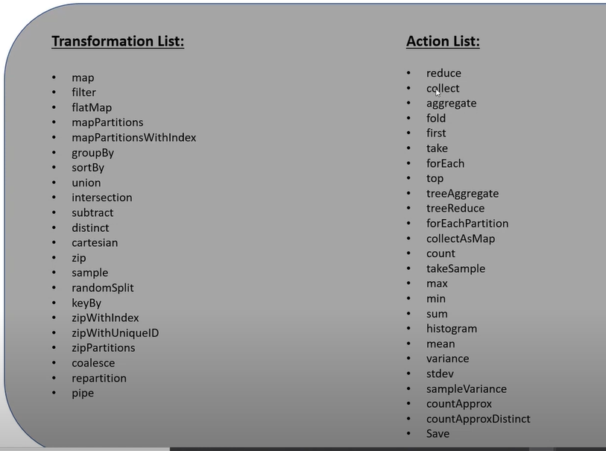

**DAG**

Directed Acyclic Graph – This is an execution map or execution plan which is created by a spark when we do any kind of transformation on the data. When we call any action on the transformed data then the **DAG is submitted to DAG scheduler.** The DAG scheduled divides the execution plan into various stages. Each stage has different task assigned. Example- Stage1 should have task1, task2. Stage2 should have task3, task4, task5.

So, the output of **DAG scheduler is a set of stages. Stages set is given as input to Task Scheduler. Task Scheduler launches** each task one by one through cluster Manager.

**TASK Scheduler:**

* Task Scheduler will check what all task is there to be processed
* It will check for the data required to execute the task. It will take help from cluster Manager to locate the data. Cluster Manager will guide task manager that data for the task is stored in system2.
* Task Scheduler will also check with Cluster Manager if there is any resource(executer/RAM) on the system to execute the task. If the resource is not there CM will initiate a resource.

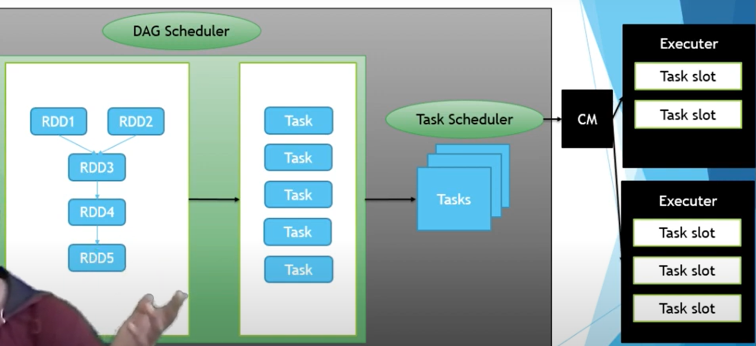

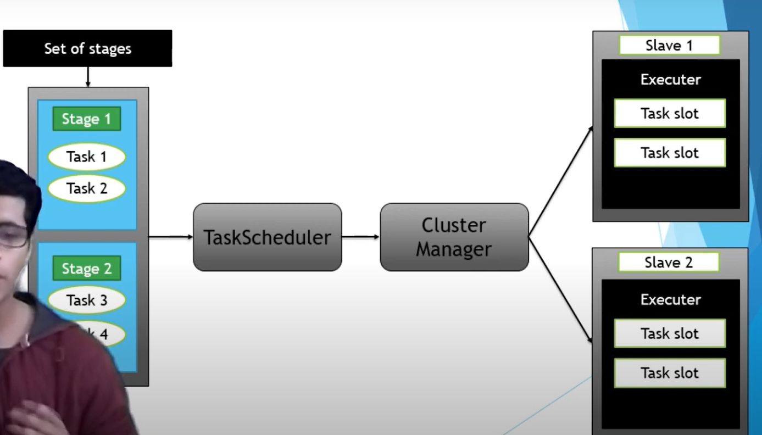

**Architecture**

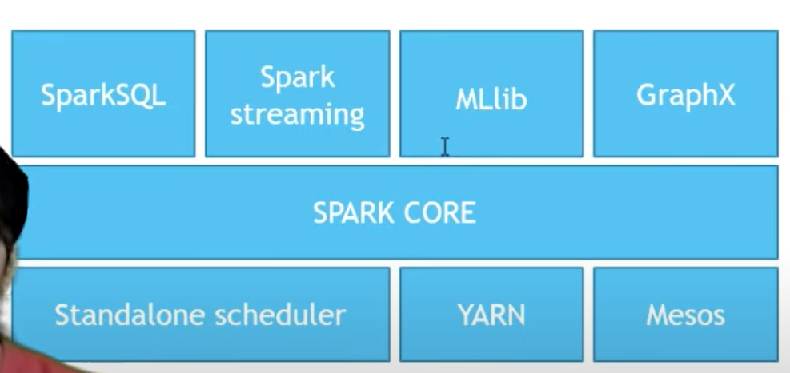

The very 1st layer in the spark architecture is cluster manager (YARN, Mesos, Standalone). One top of cluster manager resides the spark core. **Spark Core** is the main engine of spark and it take care of **scheduling tasks, memory management, fault recovery, communication with storage system.** Above the Spark core we have the components of spark like spark sql, mllib, grapx, spark streaming.

Spark follows master slave architecture as shown in screenshot below.

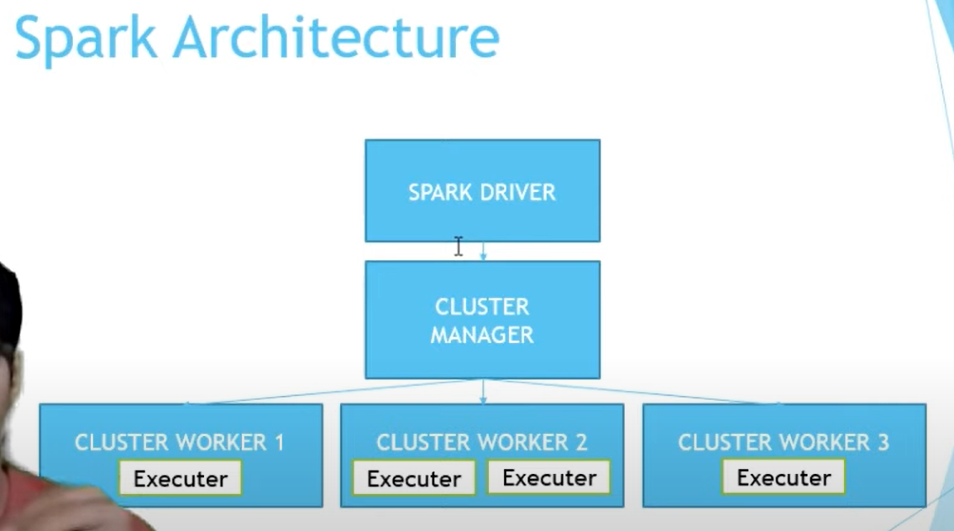

**Spark Driver (Master)**

when a job is executed on spark, The spark driver divides it into tasks. It also orchestrates the task to one or more worker node. The Spark driver does not do any computation. It communicates with cluster manager to launch the executers. The executers are responsible to execute the tasks given to them.

Spark Context is created in driver, All the DAG scheduler and Task Scheduler controls are with driver.

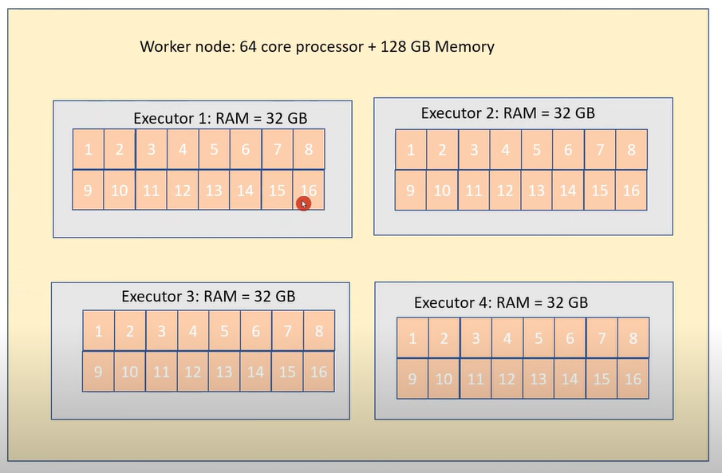

Each executers have cores. Each core process one Task.

**For Spark optimization – number of cores should be equal to multiplier of partition. Example- if we have 48 partition, then core should be 8 or 16 so that task are completed without keeping any core idle.**

**SPARK CONTEXT – (Ticket to Park)**

Spark Context is the entry point to any Spark functionality. It is a client-side object that represents the connection to a Spark cluster and is responsible for coordinating the execution of Spark jobs.

Spark Context provides various features to enable the user to create RDDs (Resilient Distributed Datasets), accumulators, broadcast variables, etc. It also manages the cluster resources and distributes the work across the nodes in the cluster.

Spark Context is created automatically when a Spark application is launched and is made available to the user through the Spark driver program. The Spark driver program is the main program that creates RDDs, applies transformations and actions to them, and then collects the results.

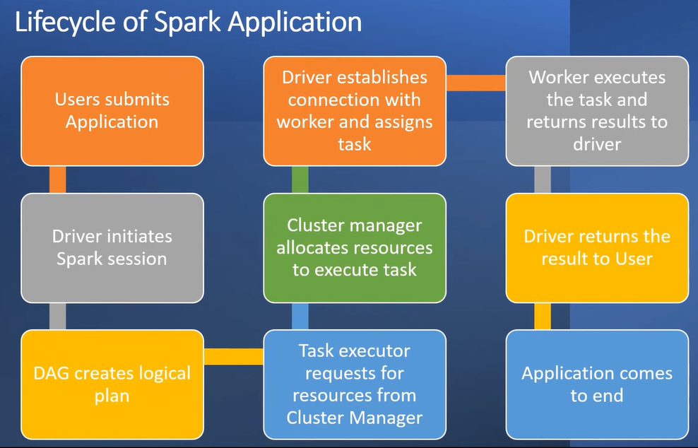

**ON Heap and OFF Heap Memory**

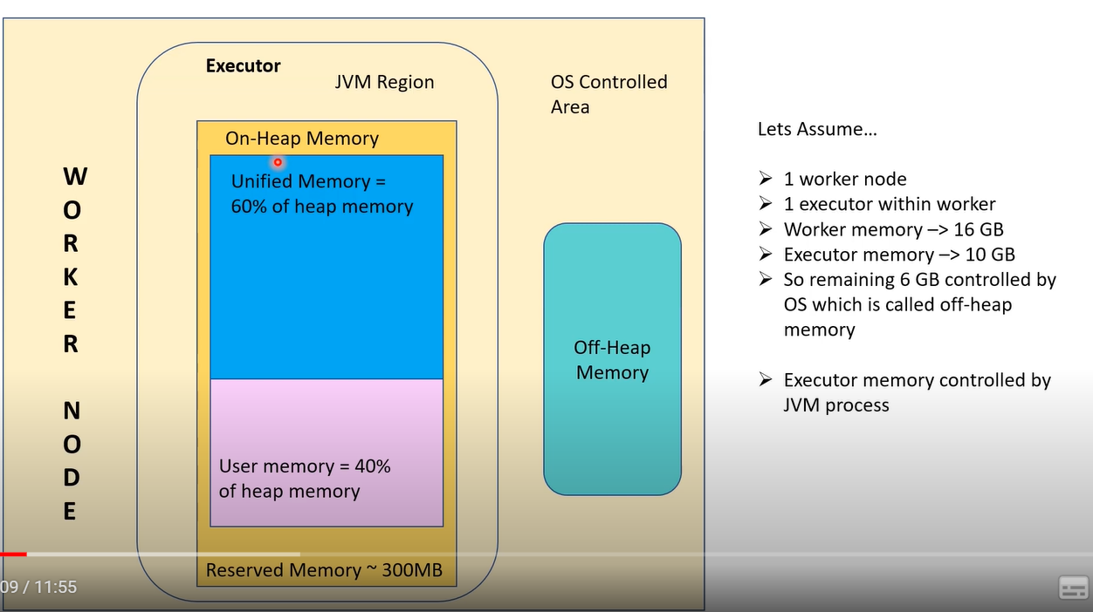

In Spark we have driver and workers node. Here we have a worker Node. Within one worker node we can have multiple executors.

* The memory allocated to executor is controlled by JVM (Java Virtual Machine). This is called as on-heap memory.
* The memory controlled by OS is called off-heap memory.
* In spark application we can use both on-heap and off-heap memory. For efficient programming we must use both the memory.

**On Heap Memory**

It contains 4 regions.

1. **Reserved Memory** - It is reserved by spark for internal purpose. If the spark crashed this memory comes in picture to recover spark.
2. **User Memory** - for storing data structure created and managed by the user’s code. When user runs code to create metadata, schema those things will be stored here.
3. **Execution Memory(Shuffle Memory)** – JVM heap space used by data structure during shuffle operations (joins and aggregations)
4. **Storage Memory** - JVM heap space reserved for cached data.

**UMM ( Unified Memory) – Execution Memory (50% of UMM) + Storage Memory (50% of UMM)**

|  |
| --- |
| **The Legacy mode of handling storage and execution in spark was called as “STATICMEMORYManager” and the new one is “UnifiedMemoryManager”.**  **In the StaticMemoryManager,** the storage and execution memory (or shuffle memory) is fixed in the configuration. The configuration parameters**spark.storage.memoryFraction and spark.shuffle.memoryFraction**governs the size of storage and shuffle memory respectively. These parameters are deprecated from Spark 1.6, and setting these parameters does not have any effect unless **spark.memory.useLegacyMode** is set to true.  **In the UnifiedMemoryManager**, the boundary between storage memory and execution memory is not fixed. Hence, storage blocks can occupy parts of execution memory if it is free and vice-versa. The parameter **spark.memory.fraction** determines the total memory dedicated to Spark (for both shuffle and storage). The amount of storage memory which is protected from eviction is governed by spark.memory.storageFraction. |

**Off Heap Memory**

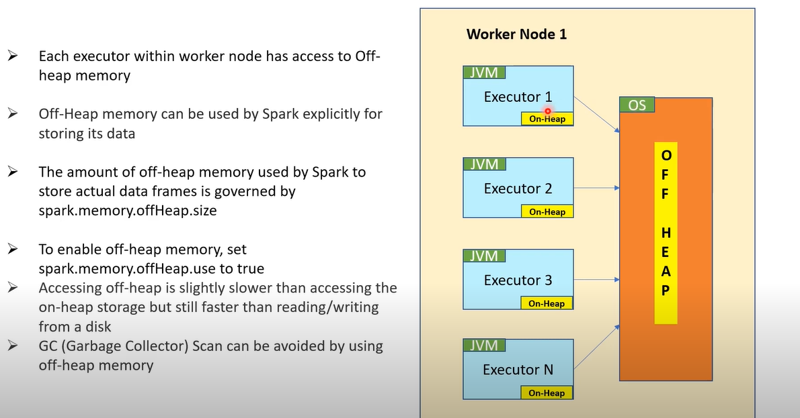

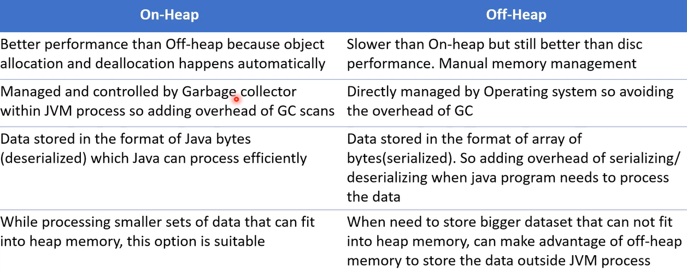

|  |
| --- |
| Although most of the operations in Spark happens inside the JVM and subsequently uses the JVM Heap for its memory, each executor has the ability to utilize an off-heap space for certain cases.  The total off-heap memory for a Spark executor is controlled by **spark.executor.memoryOverhead.** The default value for this is 10% of executor memory subject to a minimum of **384MB**. This means, even if the user does not explicitly set this parameter, **Spark would set aside 10% of executor memory(or 384MB whichever is higher) for VM overheads**. The amount of off-heap memory used by Spark to store actual data frames is governed by **spark.memory.offHeap.size**. This is an optional feature, which can be enabled by setting **spark.memory.offHeap.use to true.** |

**CLUSTER**

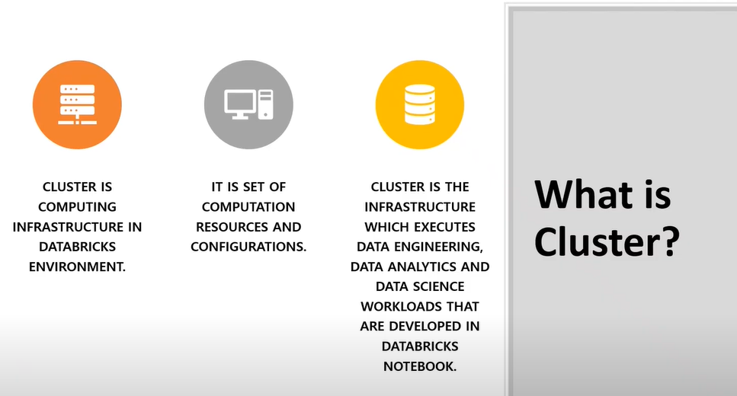

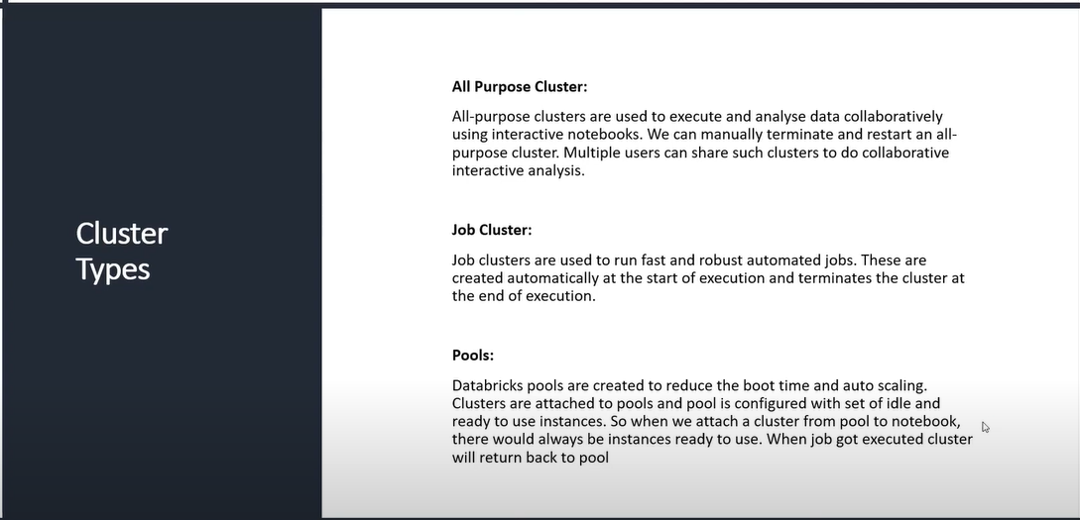

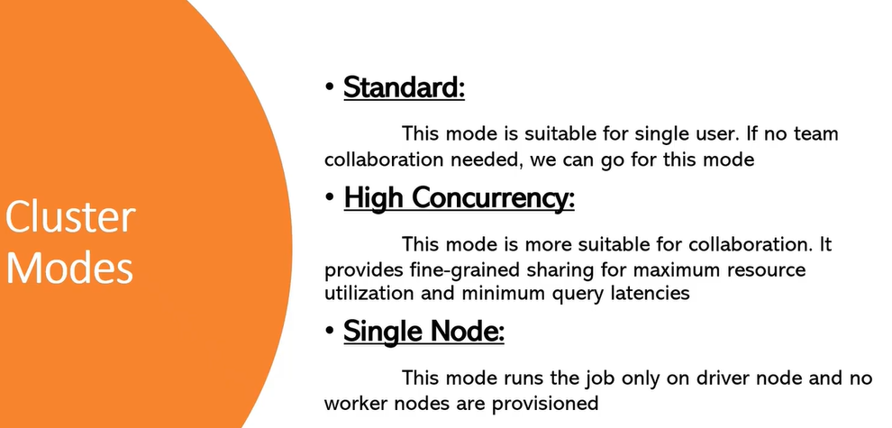

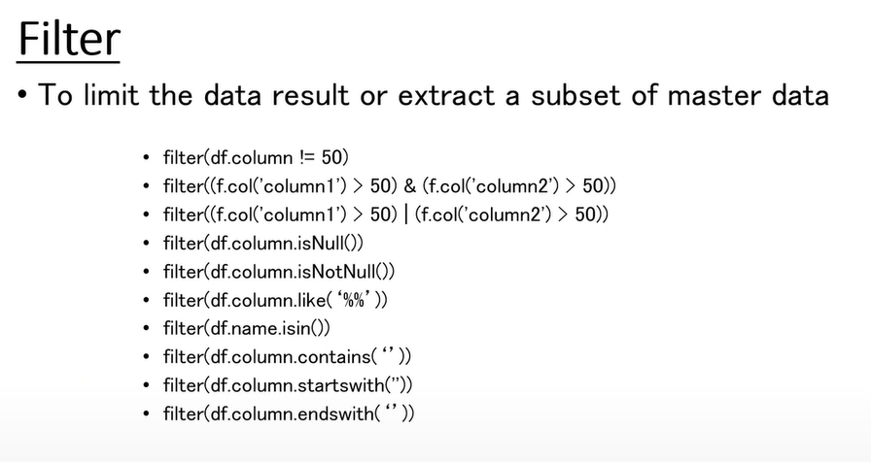

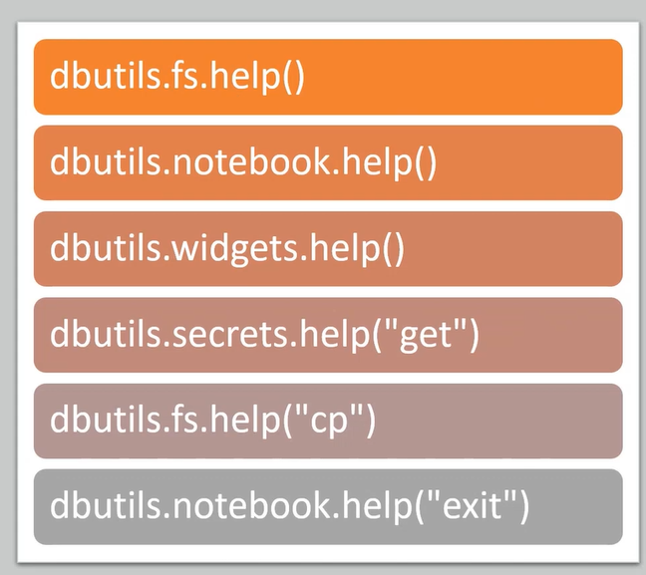

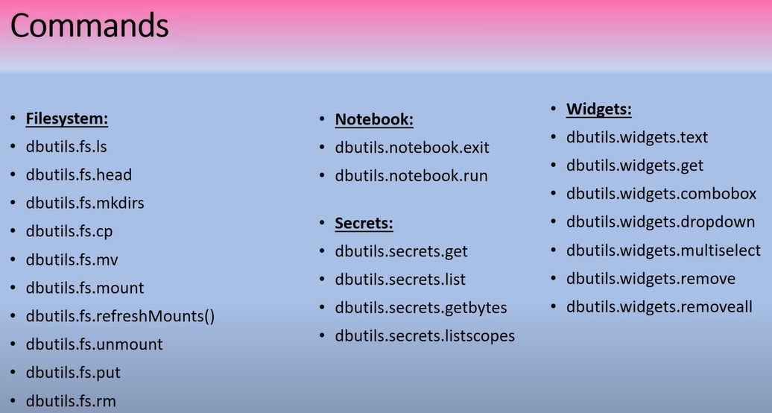

**Reading SQL database from Databricks:-**

|  |
| --- |
| jdbcHostname = "mysqlserver4444.database.windows.net"  jdbcPort = 1433  jdbcDatabase = "renewpower"  jdbcUsername = "azureuser"  jdbcPassword = "Renewtest123@"  jdbcDriver = "com.microsoft.sqlserver.jdbc.SQLServerDriver"  jdbcUrl = f"jdbc:sqlserver://{jdbcHostname}:{jdbcPort};databaseName={jdbcDatabase};user={jdbcUsername};password={jdbcPassword}"  df1 = spark.read.format("jdbc").option("url",jdbcUrl).option("dbtable","procurement.stg1_EBAN").load()  display(df1) |

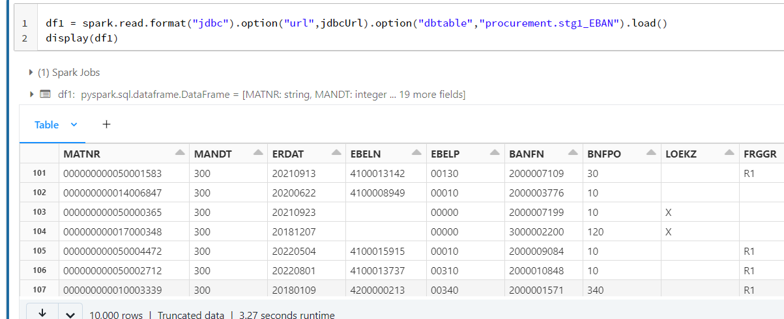

**To access Keyvault password from databricks we need to create a scope first.**

https://<databricks-instance>#secrets/createScope.

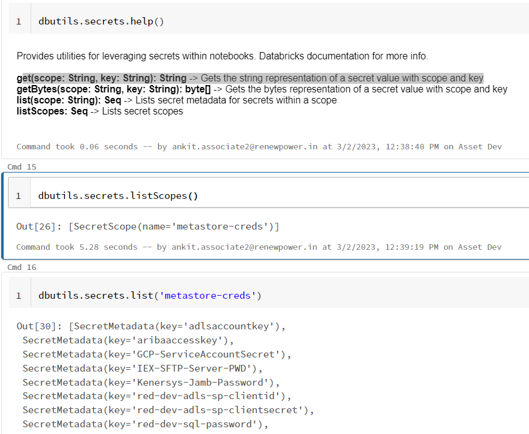

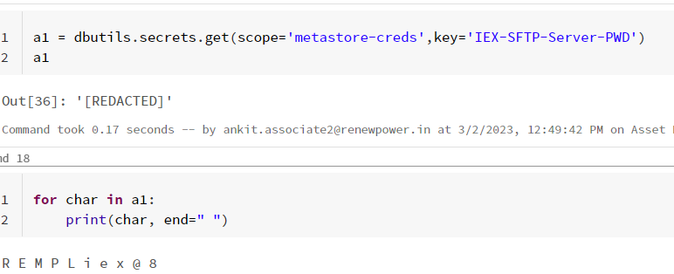

**Performance Optimization in Spark:-**

**Choosing right numbers of partitions and right size of partitions.**

* Partition is the key for performance. Best performance of any spark application involves best partition strategy.
* The right number of partitions created based on number of cores boosts the performance of application.
* Evenly distributed partition improves the performance, and unevenly distributed impacts the performance.

Lets Assume we have 16 cores executer, within that we have only created 10 partitions 🡪

So when we are triggering an actions, out of 16 cores 10 cores will pick one partition each, Partitions can’t be shared among cores. So 6 cores will sit ideal and we are not utilizing the cores effectively.

* **Partition should be equal to number of cores or in multiple of cores. (16 partition, 32, 64…etc)**

The parameter **sc.default.parallelism** determine the number of partition when creating data withine spark. Default value is 8, so it creates 8 partition by default.

When reading data from external source , partition is created based on **spark.sql.file.maxPartitionBytes** which is by default 128MB, that means is creates 128 MB partitions. For 1 GB data it would create 8 partition.

spark.conf.get("spark.sql.files.maxPartitionBytes") 🡪 Gives the default partition size

spark.conf.set("spark.sql.files.maxPartitionBytes",**209,715,200) 🡪**  This will set the default partition to 200MB

Example :-

The Individual_Incident_All2 file is 2.3 GB csv file on blob storage.

df1 = spark.read.csv("/mnt/renewdata/Ankit/TestData1/Individual_Incident_All2.csv")

df1.rdd.getNumPartitions() –-> 19 partitions of 128 MB by default

spark.conf.set("spark.sql.files.maxPartitionBytes",**”400m”) 🡪** setting 400mb partition size

df2 = spark.read.csv("/mnt/renewdata/Ankit/TestData1/Individual_Incident_All2.csv")

df2.rdd.getNumPartitions() 🡪 6 partitions are created

**Example:-**

How to process a 10GB file with Spark with following cluster resources – 16 cores and 64GB RAM.

To process a 10 GB files with Spark on a cluster with 16cores and 64GB RAM, we will need to consider a few factors to determine the appropriate executor and driver memory settings. General strategy for files beyond 8GB.

**Step1 – Determine the numbers of partitions:**

The 1st step is to determine the number of partition that the data will be split into for parallel processing. The number of partitions affects the amount of memory required per executor, as well as parallelism of the processing.

For a file greater than 10GB, a good rule is to use 2-4 partition per executor. This would be around 32-64 partition for 16 core cluster.

32 partition – 320 MB /partition

64 partition – 160MB/partition

**Step2 – Determine the executor memory:**

The executor memory is the amount of memory allocated to each executor for processing data. We will need to choose a value that is large enough to accommodate the processing requirement, not so large that it causes excessive garbage collection or other performance issue.

Formula for executor memory = (total memory available in cluster – memory allocated for other services)/number of cores

Assuming we allocate 8-10Gb of memory for other services (such as hdfs,yarn)

(64GB – 10GB)/16 executors = 3.3GB/executor

**Step3 – Determine the Driver memory:**

The driver memory is the amount of memory allocated to the spark driver program, which managers overall application. A good starting point is to allocate 1-2 GB of memory for driver program, plus additional memory if we are using caching data in memory.

**Step3 – Set the spark configuration properties:**

Once we have determined the appropriate executor and driver memory settings, we can set the spark configuration properties accordingly.

Spark.executor.memory:32GB

Spark.driver.memory:2GB

Spark.executor.cores:2

**Repartition:-**

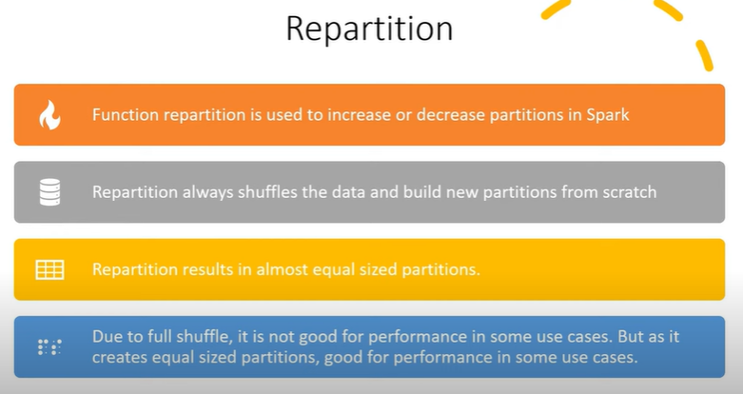

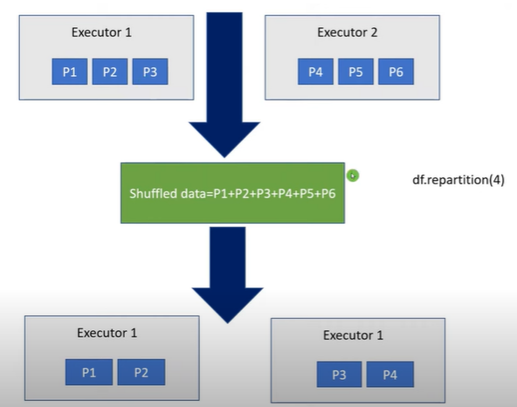

**Coalesce:-**

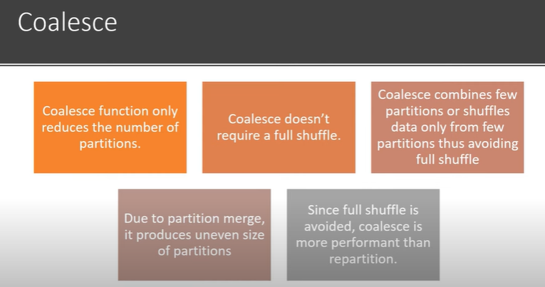

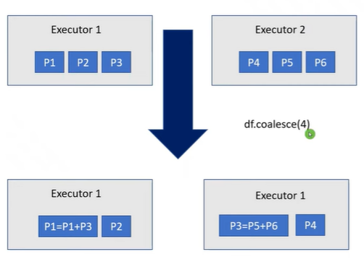

Cache vs Persist:-

* Cache is a programming mechanism which helps in storing the data in memory across the nodes.
* Persist is a programming mechanism which helps to store the data either in memory or disk across nodes.

We are creating df1,df2,df3,df4,df5 dataframes. Df2 is dependent on df1 and df1 is dependent on df. All other df3,df4,df5 are dependent on df2. So if we are calling an action on df3, df4 or df5 it will first calculate df2, which will calculate df1. So, df2 calculation is repetitive here, so we can use cache or persist to store the results of df2 and when any action is called it utilizes the cache memory to get df2 values

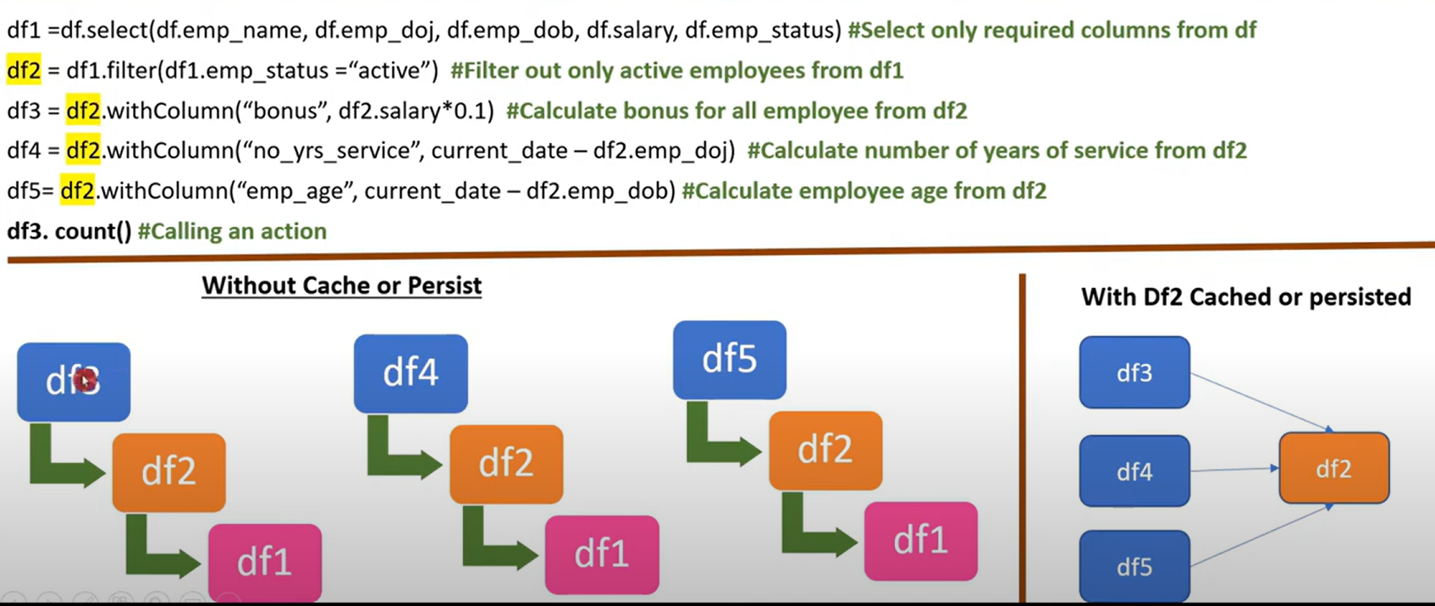

**storageLevel** is a concept in Apache Spark, which specifies how an RDD (Resilient Distributed Dataset) should be stored in memory or disk, depending on the frequency of reuse and the size of the dataset.

Spark provides several storage levels, including:

1. MEMORY_ONLY: The RDD is stored in memory as deserialized Java objects. If the RDD does not fit in memory, some partitions may not be cached and must be recomputed on the fly each time they are needed.
2. MEMORY_ONLY_SER: The RDD is stored in memory as serialized Java objects. This reduces the memory usage but increases the CPU usage for serialization and deserialization.
3. MEMORY_AND_DISK: The RDD is stored in memory as deserialized Java objects, and if it does not fit in memory, the least recently used partitions are stored on disk.
4. MEMORY_AND_DISK_SER: The RDD is stored in memory as serialized Java objects, and if it does not fit in memory, the least recently used partitions are stored on disk.
5. DISK_ONLY: The RDD is stored on disk only.
6. OFF_HEAP: The RDD is stored in off-heap memory, which is managed by the JVM but outside of the Java heap. This can be useful for very large RDDs that do not fit in the Java heap.

Bottom of Form

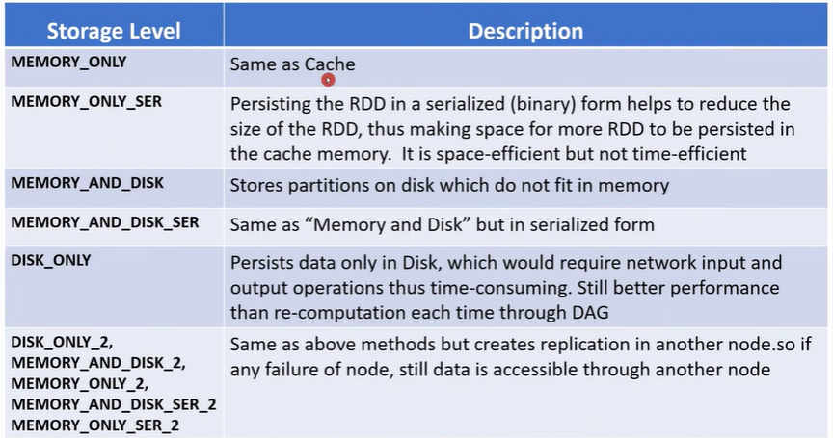

**Catalyst Optimizer:**

This is a program provided by spark to automatically find out the most efficient plan to execute data operations specified in the user code.

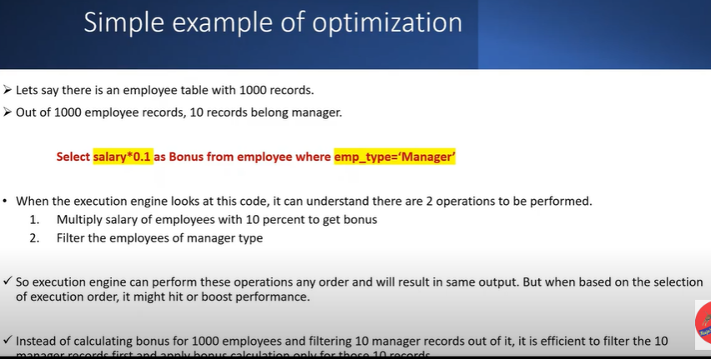

Catalyst optimizer will check for multiple execution plans to execute one particular action in dataframe, and based on that it will analyze the performance and choose the best execution plan.

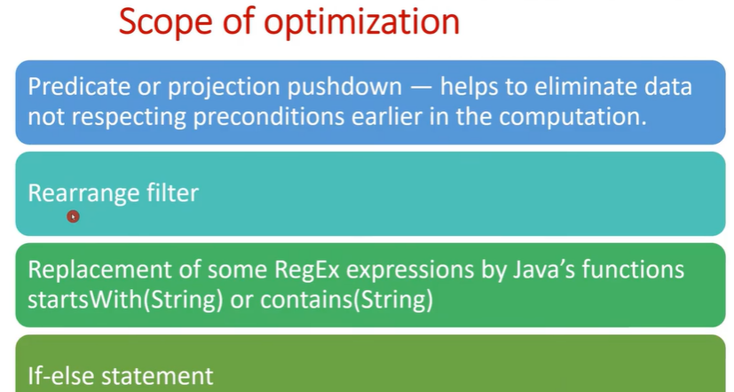

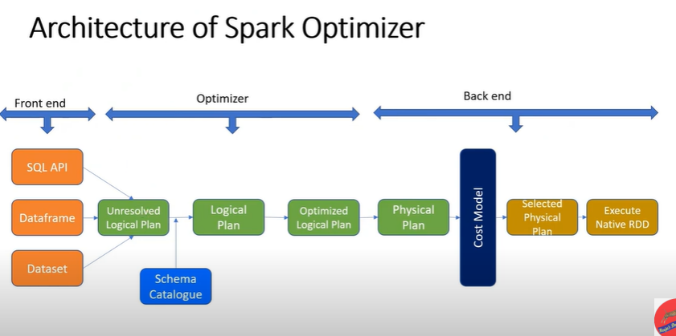

* When user submit the program from front end using dataframe, dataset or SQL API into the spark engine. The optimizer will start picking the code and start creating “Unresolved logical plan”. This is the 1st step and here the optimizer will just check for syntax.
* The 2nd step is to create the Logical plan, here it will refer to the schema catalogue for data types.
* The 3rd step is to create optimized logical plan, here it will apply different scope of optimizations like predicate or projection push down, rearranging filters, join conditions.
* The 4th step will be the physical plan, here the cost based model will come into picture and it allocates costs to each activity inside physical plan.
* Cost based model will select the best execution plan and give the executor for execution. The physical plan selected is final and the executor will follow to execute it. **Let Assume there will be 10 stages and those stages will be executed one by one.**

**Adaptive Query Execution:-**

Spark.conf.set(“spark.sql.adaptive.enabled”,True)

It is nothing but re-optimize the query during runtime.

In case of adaptive query execution the spark will start optimizing the query between the two stages. Selected physical plan will get executed. Assume there are 10 stages , the 1st stage will get executed and the results will be written into the cluster, the adaptive query will start examining that output of the 1st stage and based on that it will again start optimizing the plan.

**Broadcast Variable:-**

It is a programming mechanism in spark, through which we can keep the read-only copy of data into each node of the cluster instead of sending it to nodes each time a task need it.

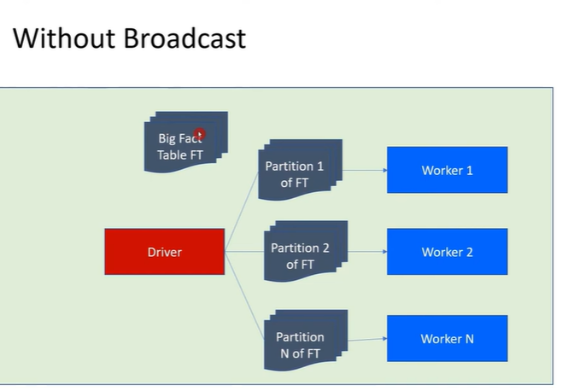

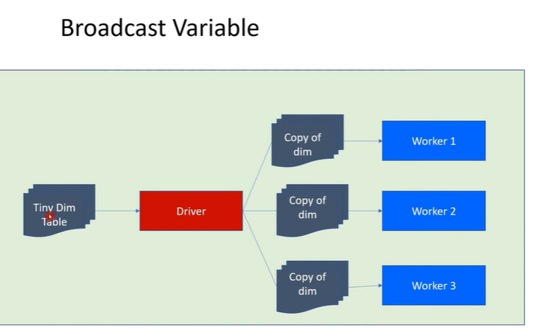

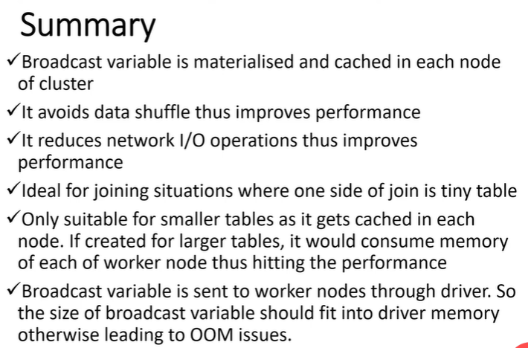

**Dataframe checkpointing.**

Dataframe checkpointing is a technique used in data processing to save the current state of a DataFrame to disk or another storage medium, such as a distributed file system or a database, for later retrieval or use. This technique is useful in cases where the DataFrame is large, and you want to save its current state to prevent recomputing it from scratch if something goes wrong, such as a system failure or an error in your code. Checkpointing a DataFrame involves saving its content to a file or another storage location, along with any metadata needed to reconstruct it. Depending on the implementation, checkpointing may involve saving the entire DataFrame or only its partitions, which are smaller chunks of the DataFrame that can be processed in parallel.

|  |  |
| --- | --- |
| **CACHE** | **CheckPoint** |
| Intermediate resultant data is written into memory. | Intermediate data is written into disk. |
| The Lineage graph retain the Lineage graph. Incase of failure the transformation can be re-computed. | The Lineage Graph is truncated once the check point is created. Ex- if we have created a dataframe checkpoint on transformation 50. The lineage graph till transformation 50 will be truncated. |

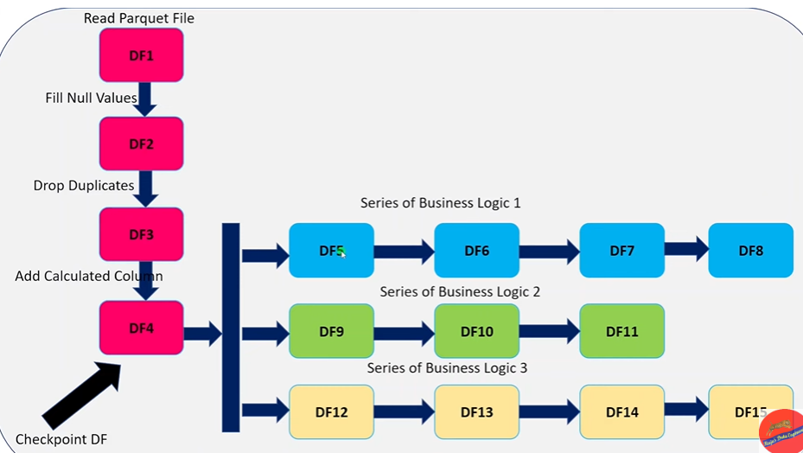

**Snappy Vs Gzip compression in File:-**

Snappy is a relatively new compression algorithm developed by Google. It is designed to be very fast and efficient at compressing and decompressing data. Snappy is best suited for use cases where speed is critical, such as in distributed computing or real-time systems. Snappy typically provides faster compression and decompression than Gzip, but at the cost of slightly lower compression ratios.

Gzip, on the other hand, is a widely used compression algorithm that has been around for many years. It is slower than Snappy, but it generally achieves better compression ratios, meaning that it can compress data more effectively. Gzip is often used for compressing larger files, such as software packages, archives, and backups.

In summary, Snappy is a good choice for use cases where speed is important and where the data being compressed is not particularly large, while Gzip is better suited for cases where the data is larger and the compression ratio is more important than the speed of compression or decompression.

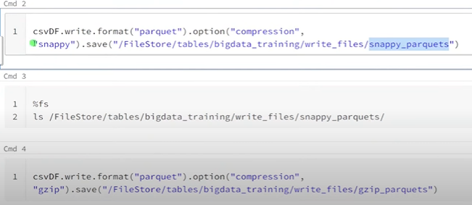

**Delta Lake**

It is an open format storage layer that delivers reliability, Security, and performance over your data lake – for both batch and streaming operations. It is extension of datalake.

By replacing Data Silos with a single home for structured, semi-structure and unstructured data, delta lake is foundation of a cost effective, highly scalable lake house.



DataWarehouse – It is one of the traditional where we do analytical processing by storing huge amount of data. DW can only deals with structure data, easier to perform any operation, easier to query data.

Creating Delta Table:

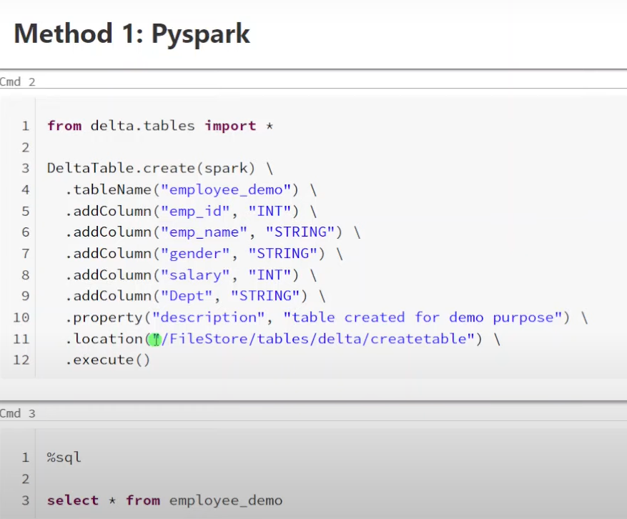

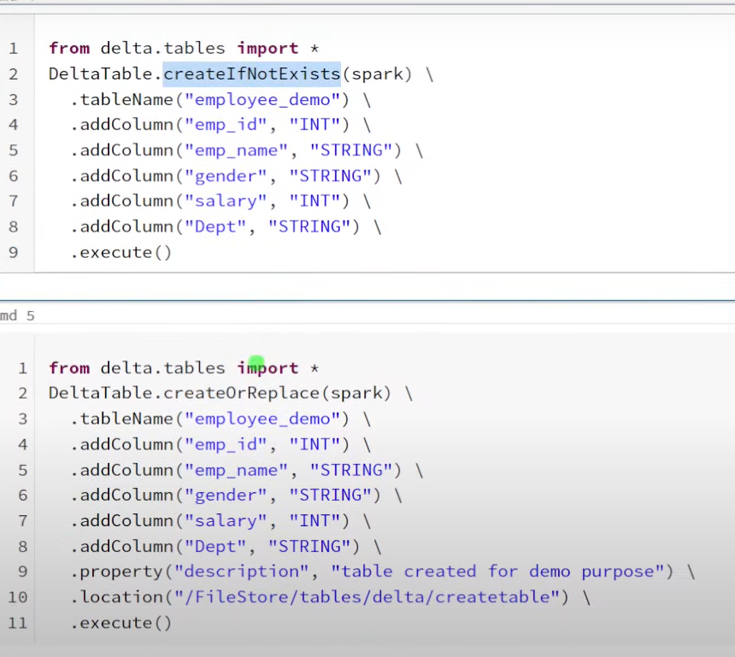

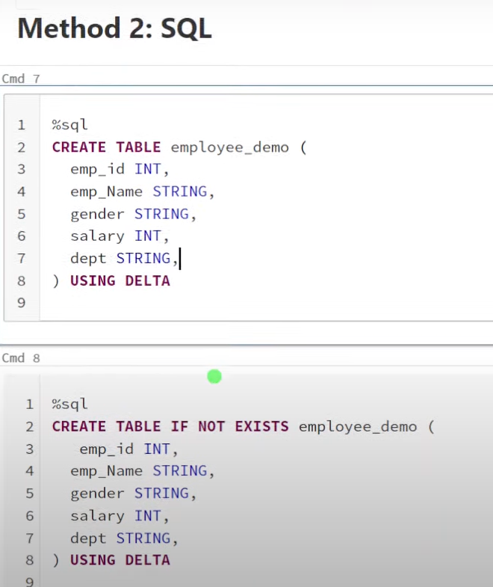

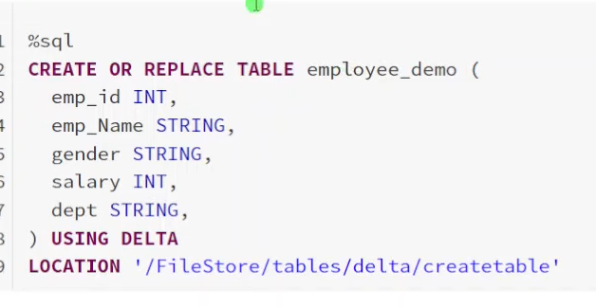

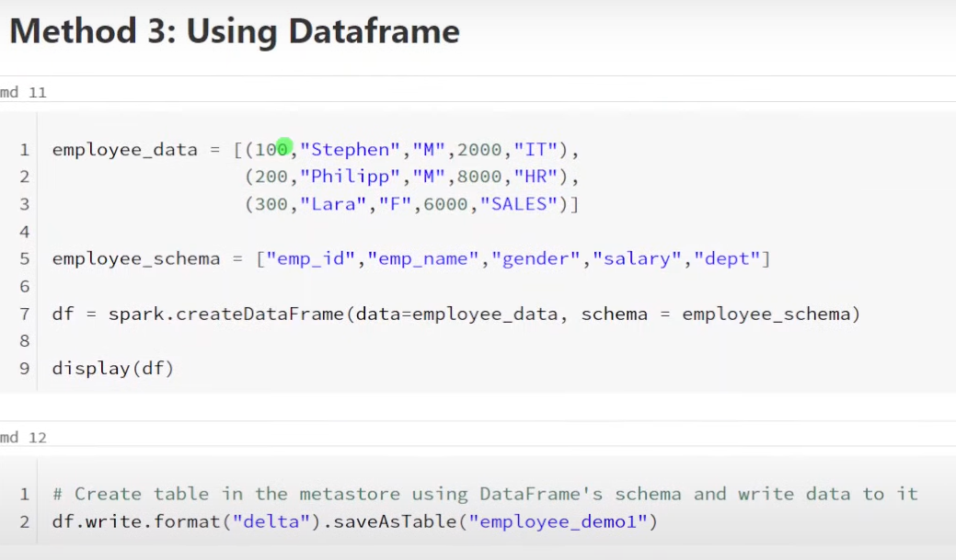

**Delta Table Instance**

Table instance will create a soft link to actual table, it will not create a copy of actual table. If you make any changes to Tables instances, it will still be reflected in actual table and vice versa.

Why need Table instance?

🡪In order to perform any DML operations we are dependent on SQL language, we do all kind of manipulation using SQL queries. There can be cases where developer don’t want to use SQL operations or the project only follow pyspark. So if we have to perform any DML operations using pyspark on a delta table we cannot do.

So for this purpose we need to create table instance.

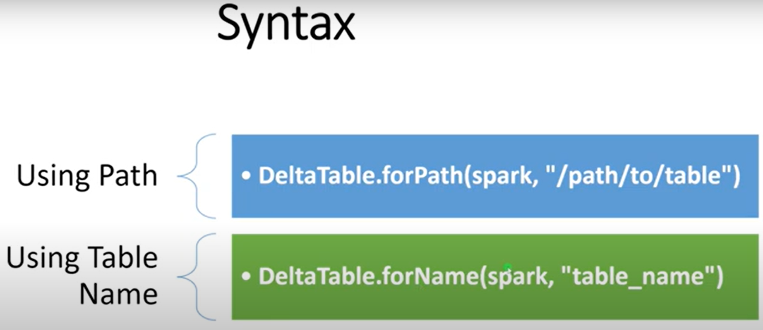

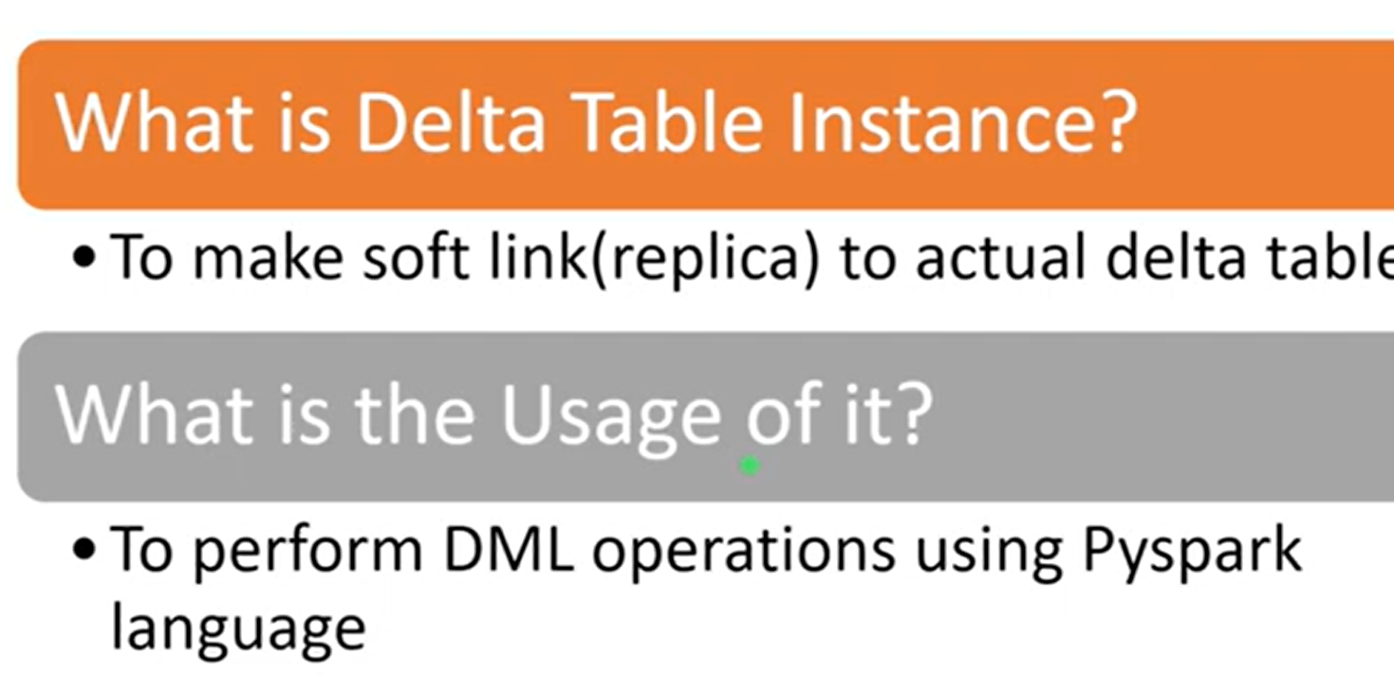

Different Approaches to Insert Data Into Delta Table

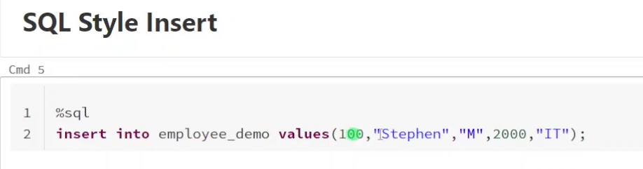

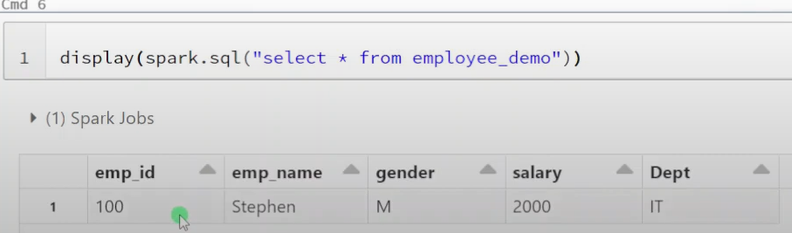

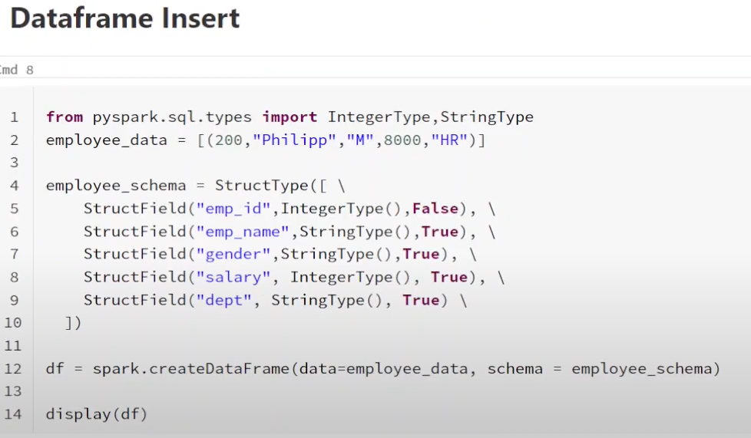

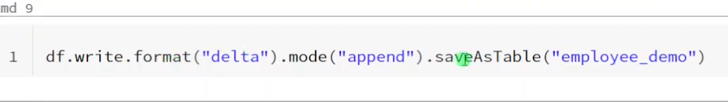

Mode – append (new data inserted on top of old data)

Mode – overwrite (truncate and load)

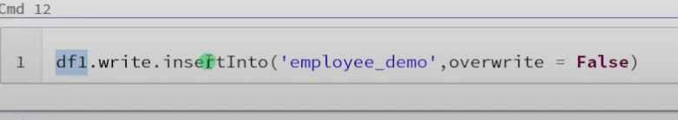

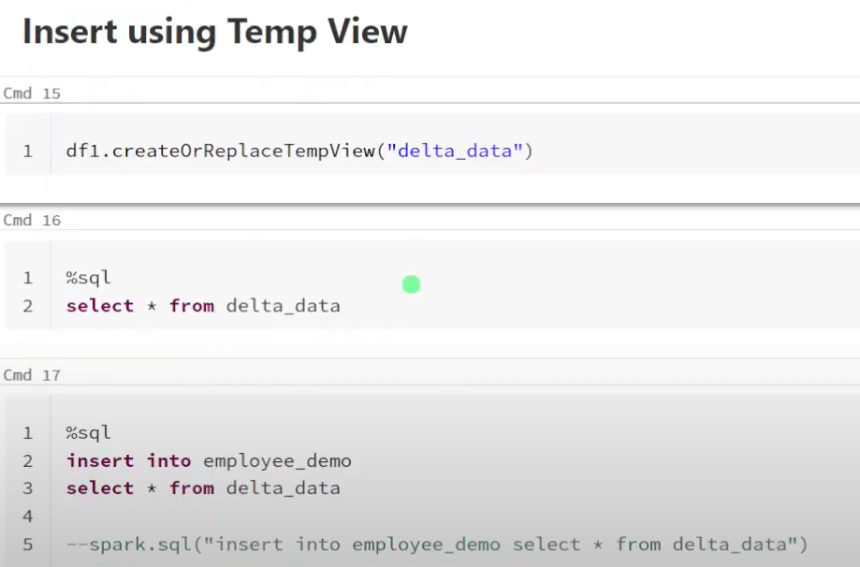

# Different Approaches to Delete Data from Delta Table

# 

# 

# 

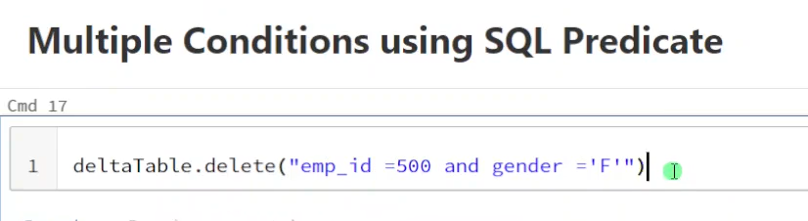

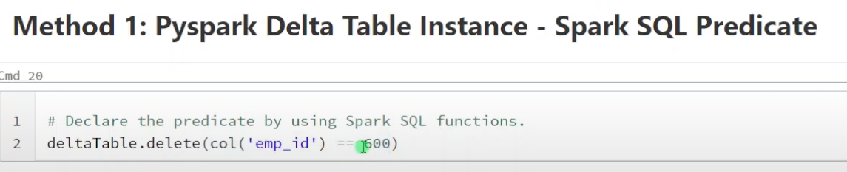

# Update Delta Table

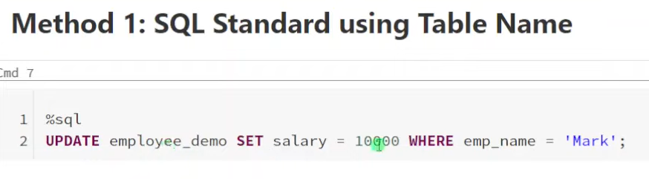

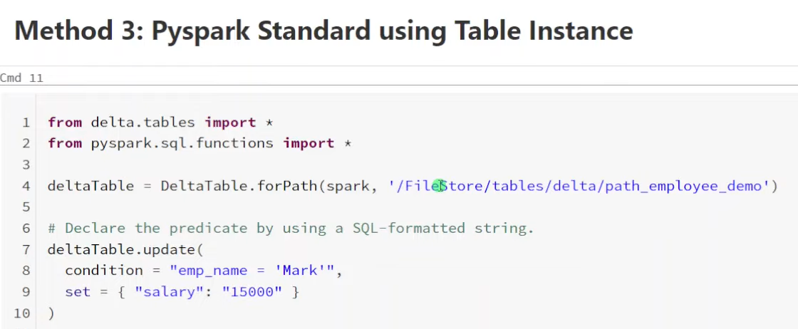

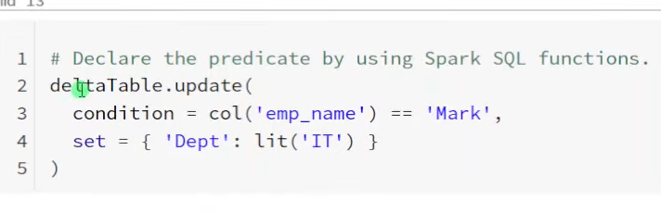

# Slowly Changing Dimension|SCD Type1| Merge using Pyspark and Spark SQL

# Merge or Upsert Operation – When we have to update the target table based on the latest incoming source data, we have to compare the data.

# Match – if there is a match found, target data will be updated based on the source.

# No Match – New data, it will be inserted

# 

# 

# 

# 

# >>>> Pyspark Methord

# Source

# 

# Target

